Tableau Example

Here are some examples and screenshots (with mocked up and masked data) from projects I have worked on.

The first example is an example of how Tableau can be used for KPI or SLA reporting. The data can come from a variety of sources for a report like this, but the end result is a clean one page dashboard that shows indicators of the performance of the different teams and processes.

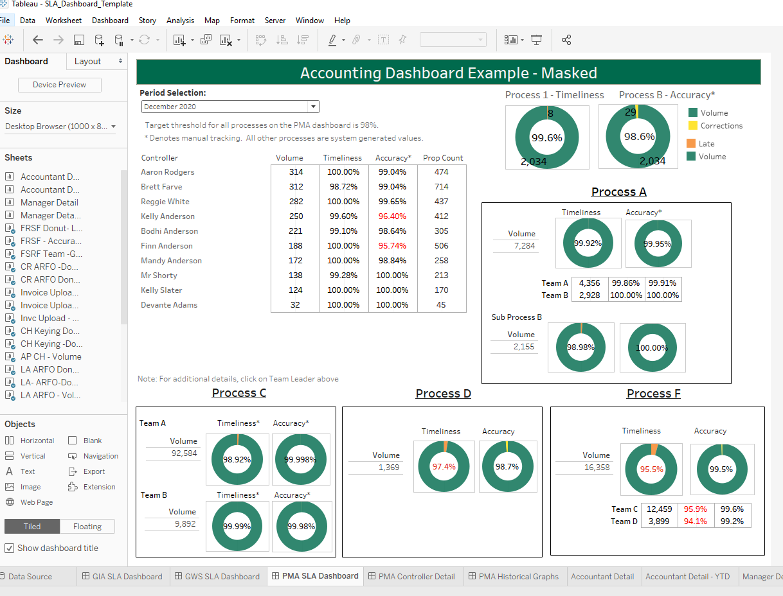

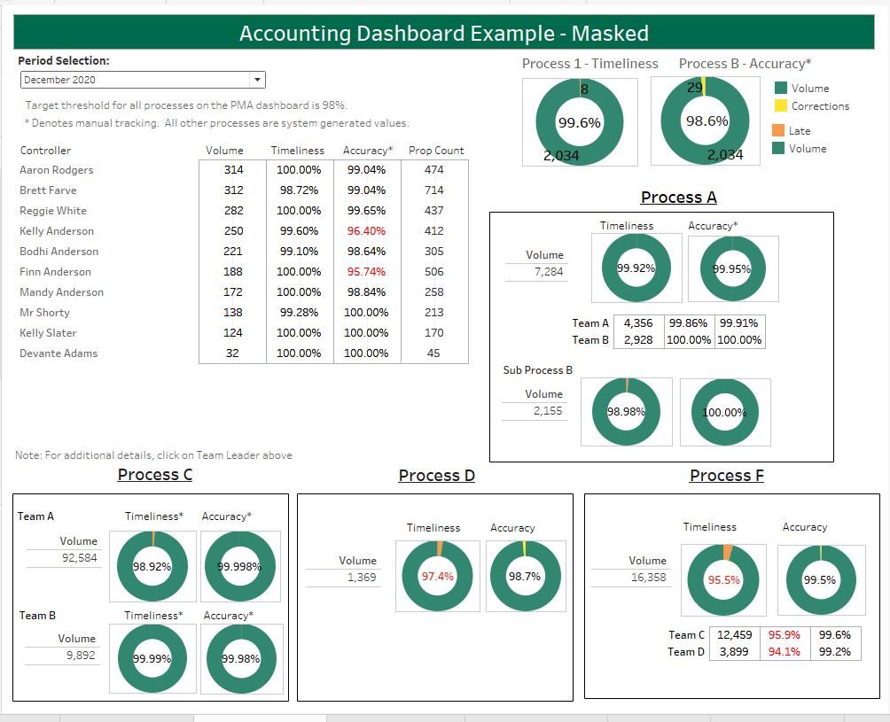

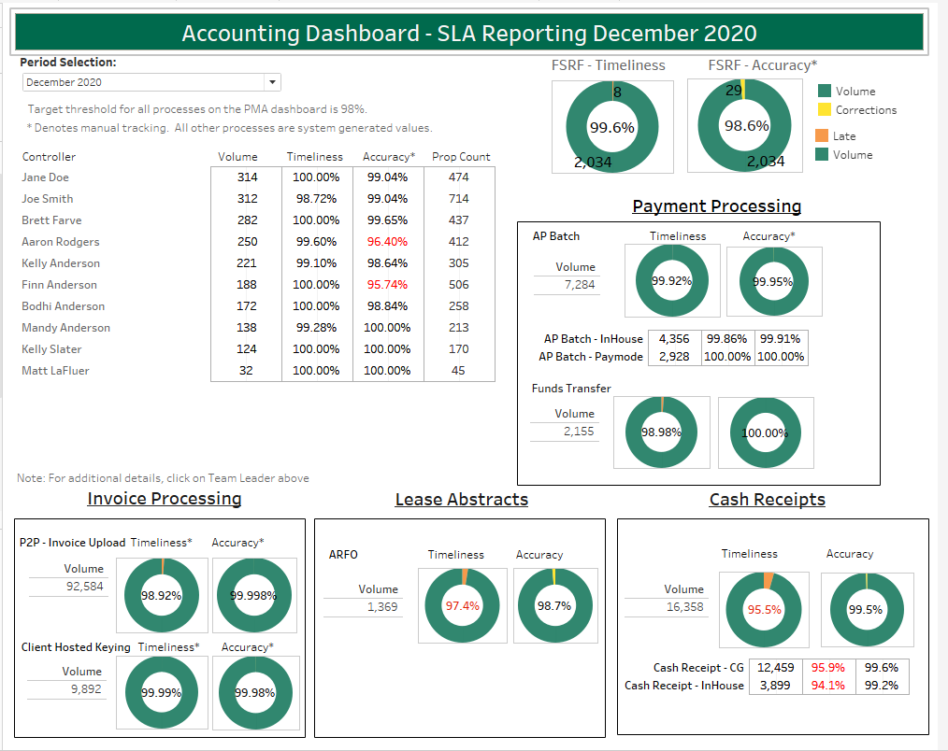

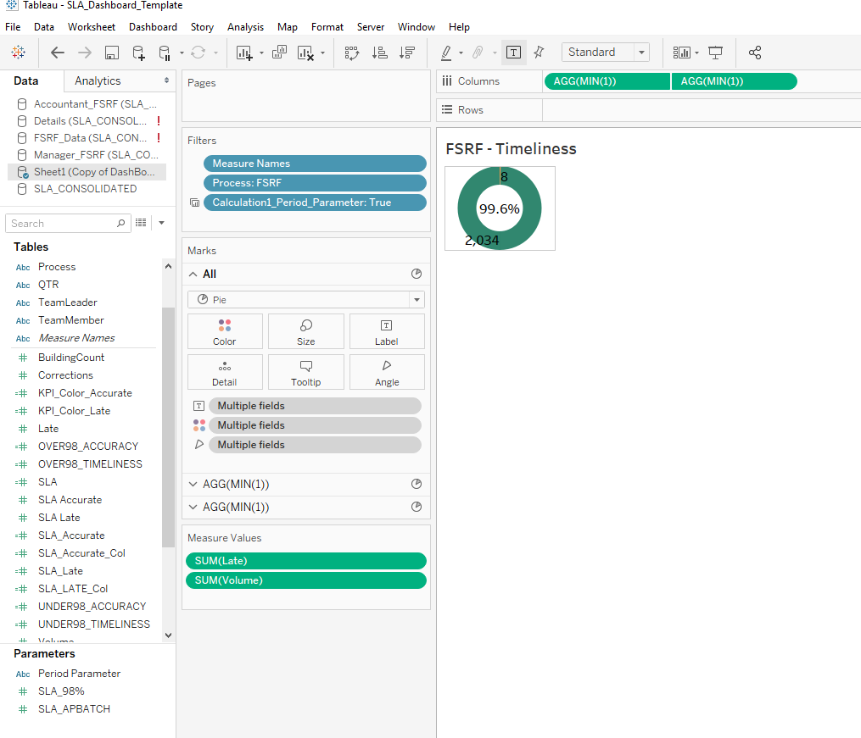

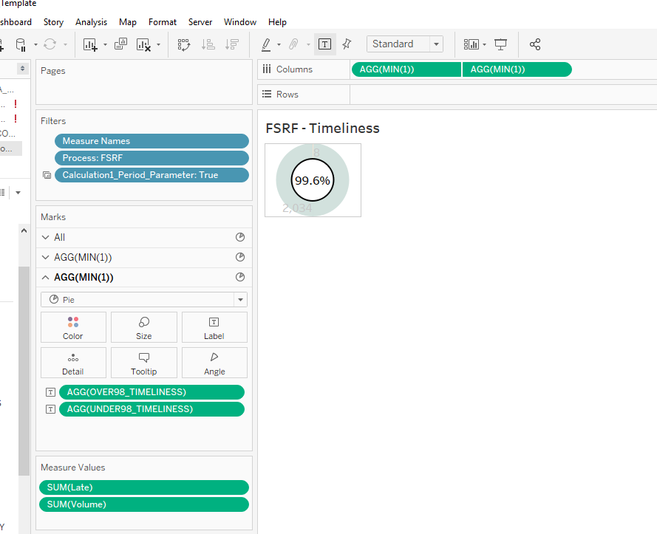

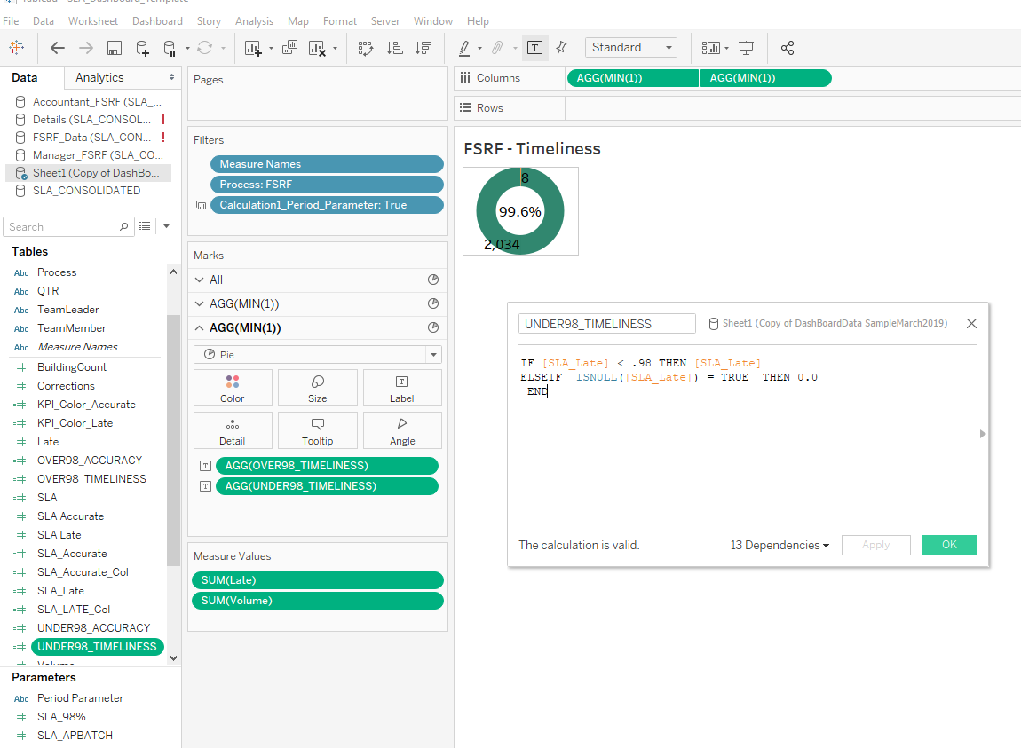

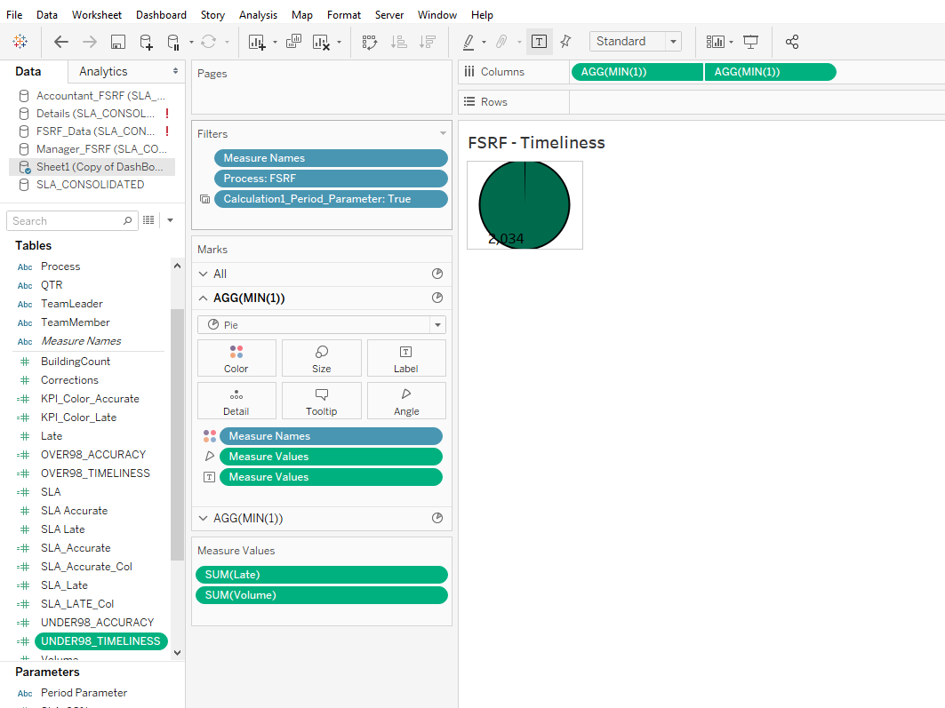

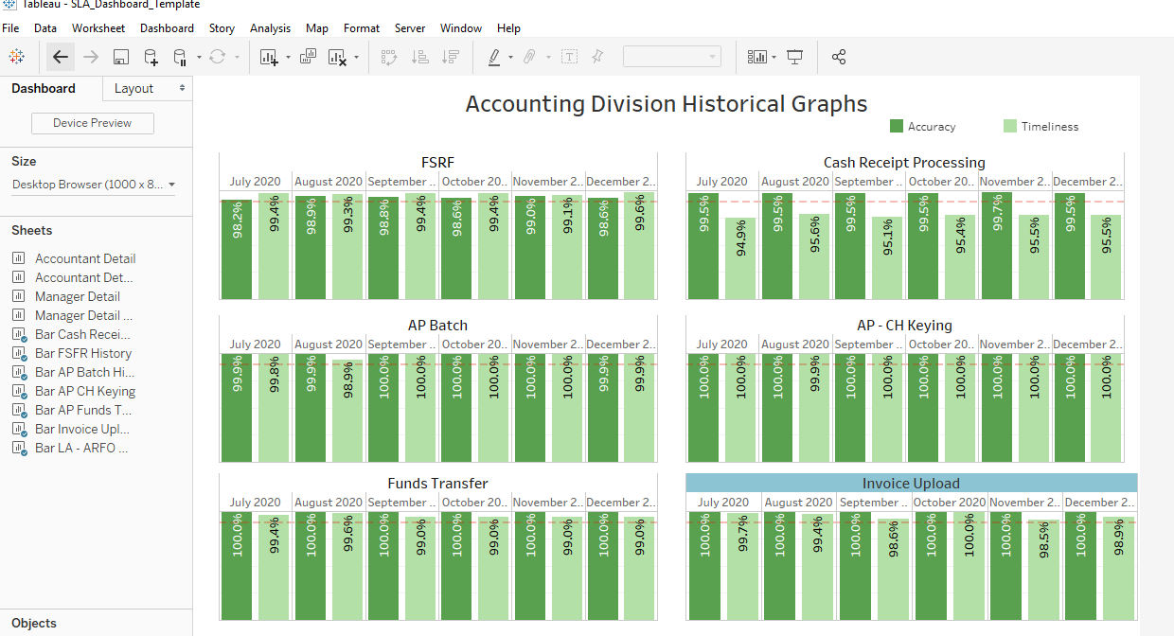

Another example of how we can use Tableau is a dashboard that compares two periods, to see trends against the data. The actual numbers have been removed in this screenshot, but the graphs give a quick picture into the period comparisons of the data. There are also a number of filters that make slicing and dicing the comparisons very easy and extremely useful in finding the trends and changes in the data.

